TERM-II PROJECT REPORT
PCCCS495 – Programming with Java

Course Name: Programming with Java (PCCCS495)
Project Title: Adaptive Study Strategy Engine
Student Name: Shreya Sinha
Roll Number: 26
Instructor Name: Soumadip Biswas, Dr. Susovan Jana
Semester: 4th

2. PROBLEM STATEMENT
Students often face difficulty managing multiple subjects and topics during exam preparation. Traditional study planners require manual prioritization and lack adaptability when performance changes. As a result, students tend to focus on already strong areas while neglecting weaker topics, leading to inefficient study patterns.
The Adaptive Study Strategy Engine solves this problem by dynamically adjusting study priorities based on mastery levels. Each topic is represented as an object containing attributes such as name and mastery level. The system evaluates performance and automatically reorganizes study tasks using a priority-based scheduling mechanism.
This ensures that weaker topics receive more attention and study time is utilized effectively.

3. SYSTEM DESIGN
UML Class Diagram:
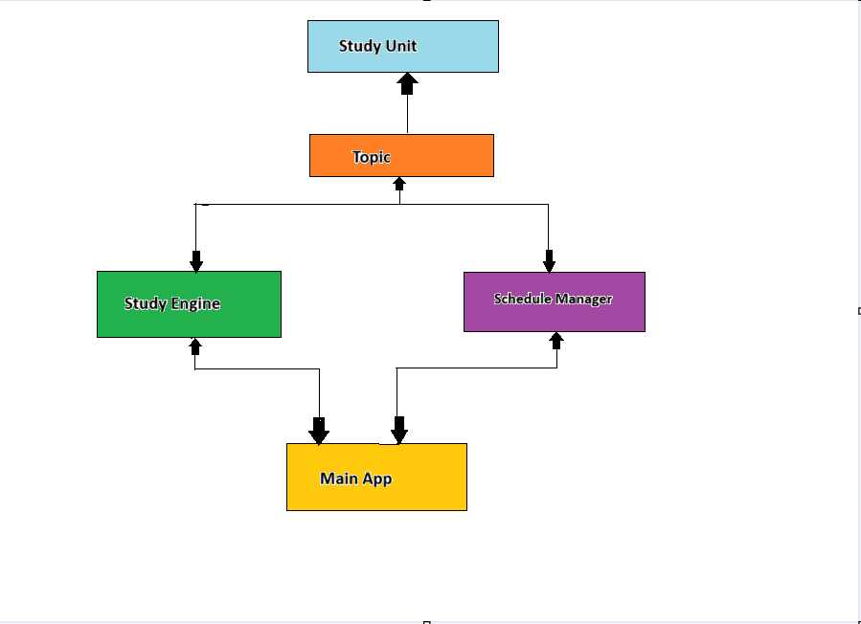

Package Structure
src/
├── model/
│ ├── StudyUnit.java
│ ├── Topic.java
│
├── engine/
│ ├── StrategyEngine.java
│ ├── ScheduleManager.java
│
├── ui/
│ ├── MainApp.java
│
├── storage/
│ ├── PersistenceManager.java
Major Classes Description
🔹 StudyUnit (Abstract Class)
- Contains: name, masteryLevel
- Defines: calculatePriority()
🔹 Topic
- Extends StudyUnit
- Implements priority logic
🔹 StrategyEngine
- Analyzes performance
- Suggests focus areas
🔹 ScheduleManager
- Uses PriorityQueue
- Maintains dynamic scheduling
🔹 MainApp
- Swing GUI interface
- Handles user input/output

Interaction Flow
- User inputs topic name and mastery level
- MainApp receives input
- StrategyEngine analyzes performance
- ScheduleManager stores and prioritizes tasks
- Output displayed to user

4. OOP CONCEPTS DEMONSTRATED

- Abstraction
Where used: StudyUnit class
Why used: To define common structure
public abstract class StudyUnit {
protected String name;
protected int masteryLevel;
public StudyUnit(String name, int masteryLevel) {
this.name = name;
this.masteryLevel = masteryLevel;
}
public abstract int calculatePriority();
}
Explanation: Abstract class ensures all study units follow same structure.

- Inheritance
Where used: Topic extends StudyUnit
Why used: Code reuse
public class Topic extends StudyUnit {
public Topic(String name, int masteryLevel) {
super(name, masteryLevel);
}
public int calculatePriority() {
return 100 - masteryLevel;
}
}
Explanation: Topic inherits properties and customizes behavior.

- Polymorphism
Where used: calculatePriority()
Why used: Dynamic behavior
Same method behaves differently based on class implementation.

- Encapsulation
Where used: Protected variables
Why used: Data security
public String getName() {
return name;
}

- Collections
Where used: PriorityQueue
Why used: Automatic sorting
PriorityQueue<StudyUnit> queue =
new PriorityQueue<>((a,b) -> b.calculatePriority() - a.calculatePriority());

- Swimlane Modeling
Where used: System flow
Helps visualize interaction:
User → MainApp → StrategyEngine → ScheduleManager → Output

5. IMPLEMENTATION HIGHLIGHTS

- Snippet 1: Priority Calculation
return 100 - masteryLevel;
Justification: Lower mastery → higher priority

- Snippet 2: Scheduling Logic
queue.add(unit);
Justification: Adds tasks dynamically

- Snippet 3: Display Schedule
while (!temp.isEmpty()) {
StudyUnit u = temp.poll();
result += u.getName();
}
Justification: Displays sorted tasks

6. TESTING & ERROR HANDLING

Test Cases
Input | Expected Output
Math, 40 | High priority
Physics, 80 | Low priority

Edge Cases
- Empty topic name
- Invalid mastery value
- Non-numeric input

Failure Handling
- Try-catch for invalid input
- Validation checks for range

7.GIT WORKFLOW
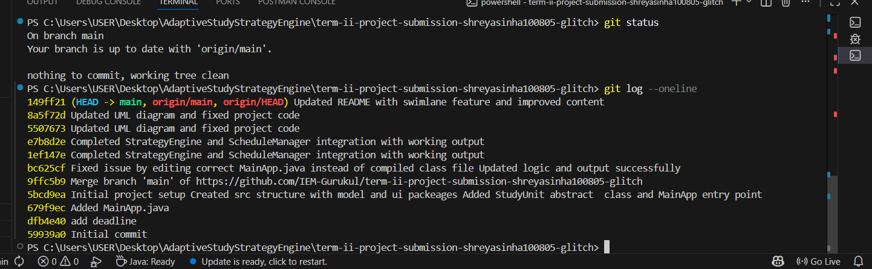

8. CONCLUSION & FUTURE SCOPE
The Adaptive Study Strategy Engine provides an intelligent solution for managing study tasks. It ensures better time management by focusing on weaker areas. The project demonstrates strong object-oriented design and workflow modeling.
Future Scope
- Deadline-based scheduling
- Database integration
- Android app version
- Analytics dashboard

APPENDIX
1. Review Mail (APPROVED_MINOR)
